**SQL SERVER ANALYSIS SERVICES**

We use the SSAS for building a multidimensional database (MOLAP) from our dimensional database (Data Warehouse). The Final end result will be a user facing data structure called as a cube. This cube has different decided dimensions along the edges, which can be used to drill across data for analytical tasks. The properties of the dimensions can be changed to display something simpler to the end user and also we can create the hierarchies of data so that it is organized in meaningful sequences and pre-calculate data for performance improvements. The attributes and hierarchies are as follows:

**Dimension Dates:**

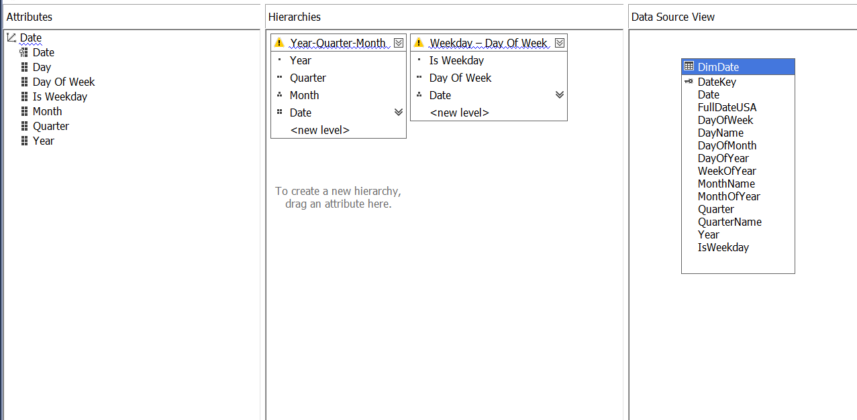

**Dimension CustomerAccount:**

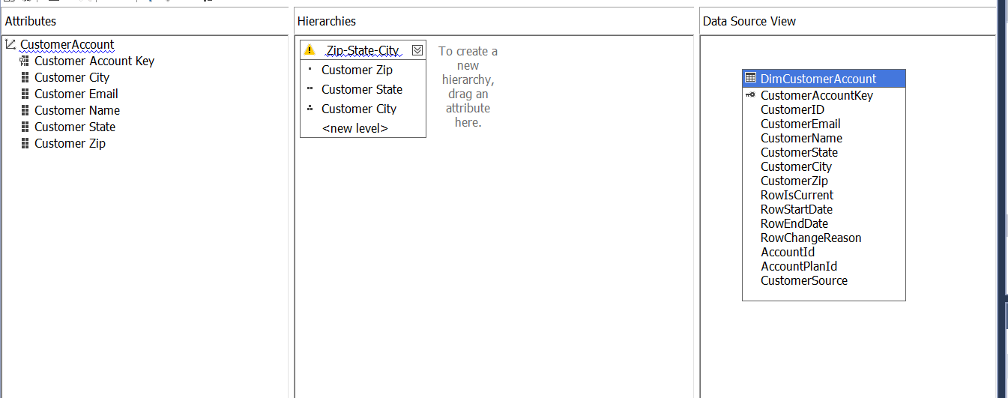

**Dimension Account:**

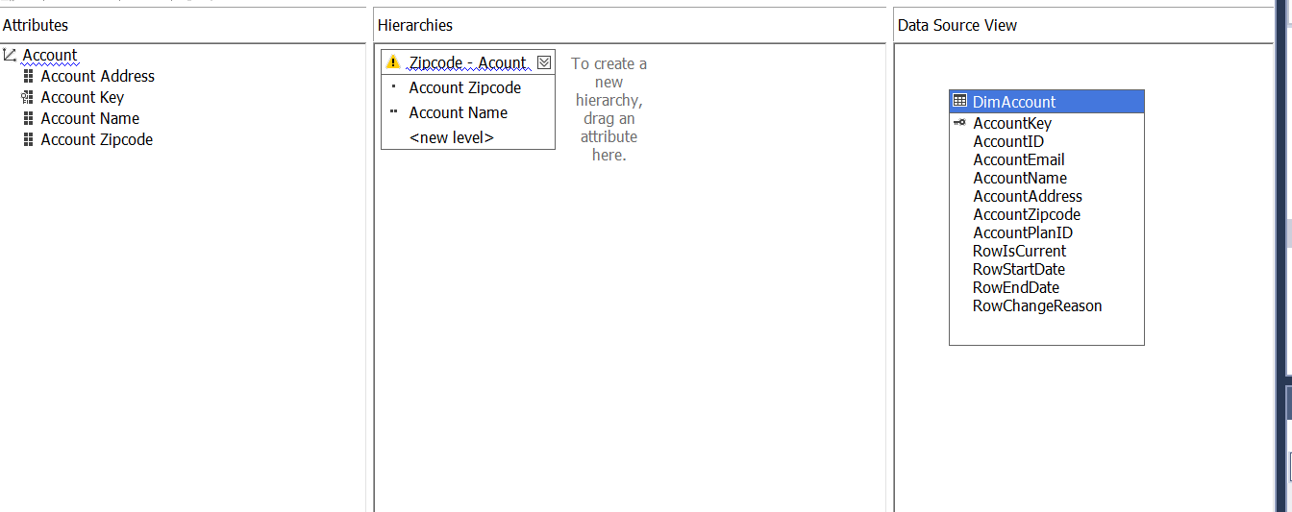

**Dimension Plan:**

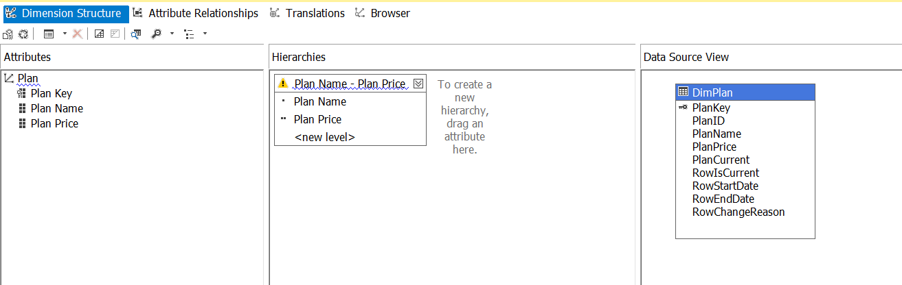

**Dimension Product:**

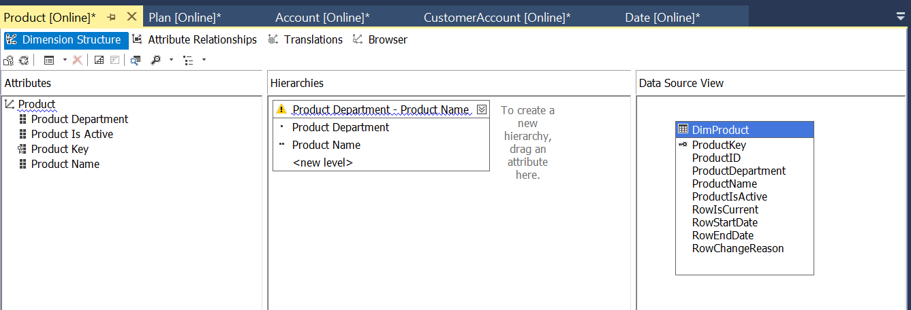

**Dimension Title:**

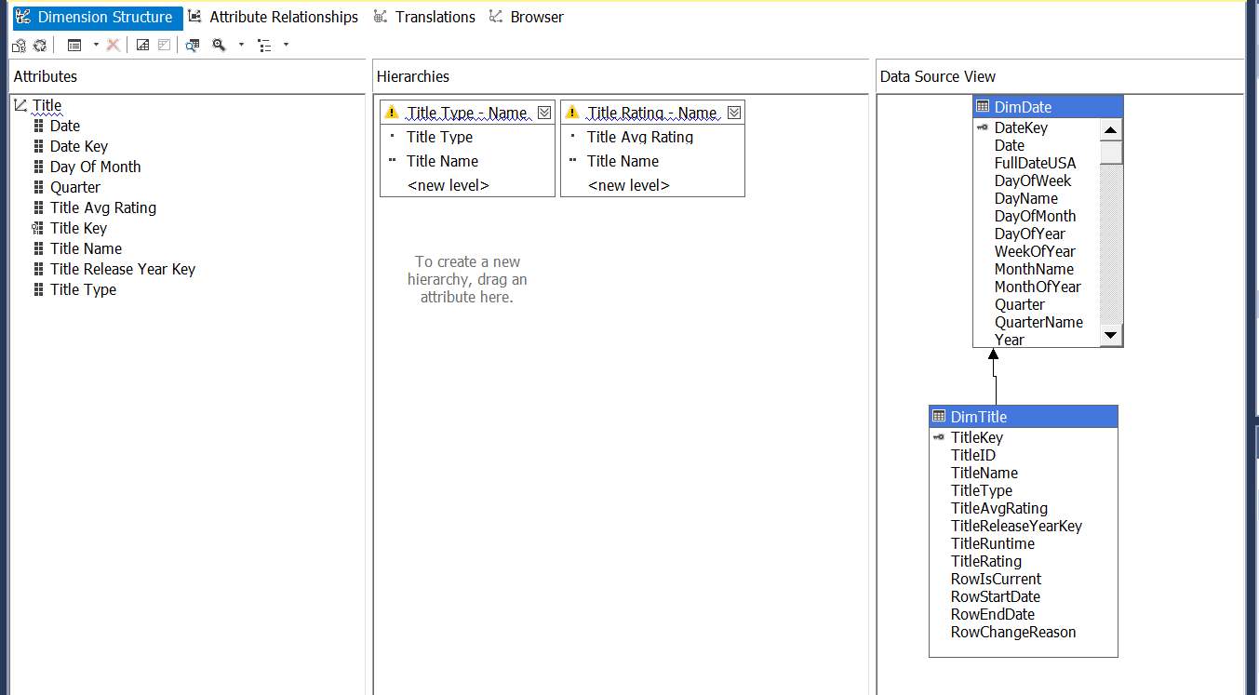

**Fact Delivery Efficiency:**

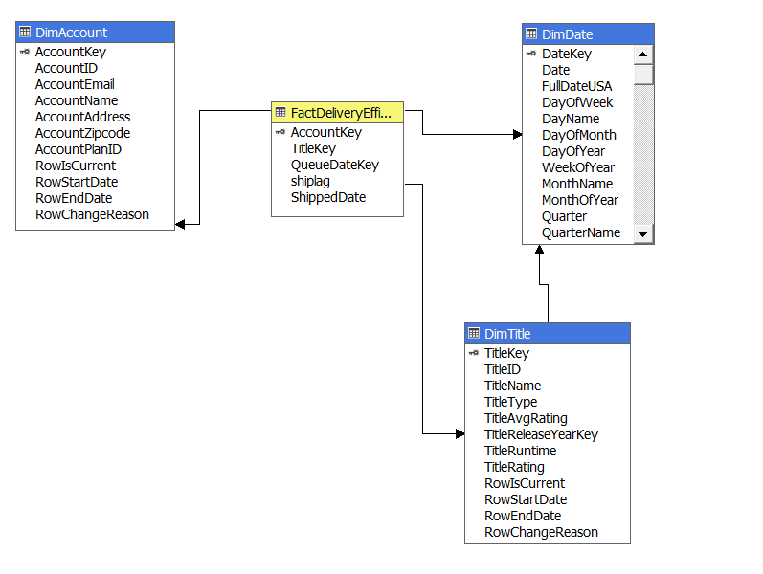

**Fact Customer Review:**

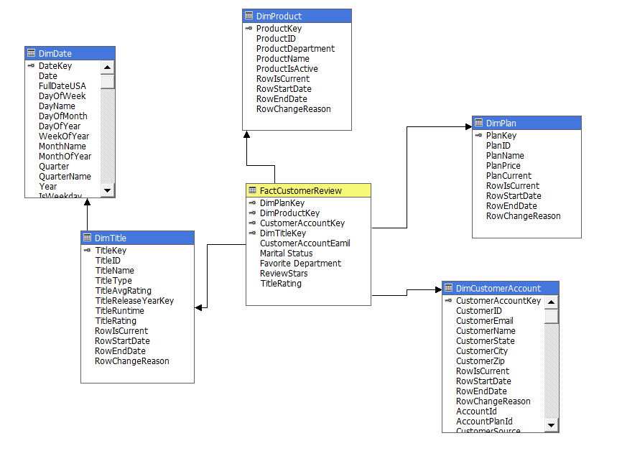

**SSAS Diagram:**

